Boaz

0700886058

COMPERENSIVE LEARNERS COMPTETENCY GUIDE FOR ICT BEGINNERS

COMPUTER PACKAGES (CERTIFICATE)

* *ICT ESSENTIALS (introduction).*
* *WORD PROCESSORS (MS. Word).*
* *SPREADSHEETS (M.S Excel).*
* *DBMS (MS. Access).*
* *PRESENTATIONS (MS. PowerPoint).*
* *DTP (MS. Publisher).*
* *INTERNET AND NETWORKING.*

**Boaz**

**INTRO DUCTION TO COMPUTER.**

**Definition of a computer**

1. Is an electronic device that accepts user input (data) and transforms it under set of instructions to produce an output (information).
2. An electronic device that is capable for manipulating data into information.

**Terms used in a computer**

***Data*** : Are raw facts that are meaningless o the user and cannot be used to make any decision e.g.

Numbers, Letters, and Symbols when inserted.

***Processing***: Is the changing of data is into information.



***Information***: Is the processed data (meaningful data).

***Ports*** *:* Are openings where external connections can be done. They include;

* Power ports
* PS2 ports (Mouse and keyboard)
* Ethernet ports
* Serial ports
* Parallel ports
* VGA and display ports (VGA, HDMI, gaming)
* Printer ports
* Input/output (speakers, microphone, Line in)

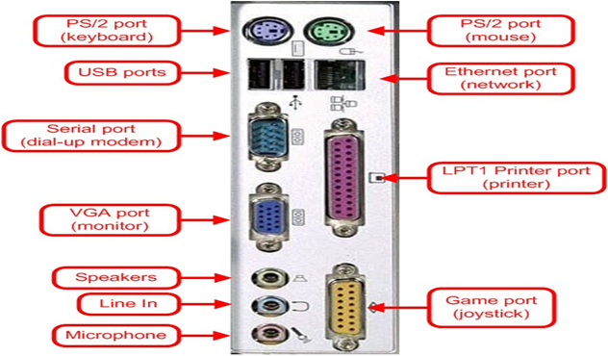

**PARTS OF A COMPUTER**

A computer is divided into three major parts:

1. Live ware
2. Hardware.
3. Software.

***Computer liveware***

1. This is the person operating the computer

**A. Computer hardware.**

They are physical and tangible components of a computer. They are the computer parts which can be seen and physically touched.

**Divisions of computer hardware.**

* Input devices
* Output devices
* Storage devices

**Input devices**

They deal with data entries and feeding the computer with facts. It can be achieved through capturing, typing, tapping or voice emulations.

Examples of input devices;

1. **Mouse.**

A hand riven device used for controlling the pointer display on the screen. It is an example of a pointing device. Other pointing devices include gaming pads, track ball, joy sticks, touch pads.

1. **Keyboard**

Typewriter like device used to key in data in form of characters and instructions to the computer. The most commonly used keyboard is QUERTY; the name is derived from the key configurations and arrangements. Other keyboard types include number keys in calculation gadgets such as electronic calculators and on-screen keyboard on window systems.

1. **Scanners**

Converts hard copy data such as on papers to soft copy. Most scanners are commonly found in printers and others include flatbed and android based scanners.

1. **Cameras**

Captures both static and motion objects and records on a tape as an image.

1. **Screens**

An input device which works in the place of keyboard, mouse or OCRs.

1. **Barcode readers**

A device that captures and interprets the information encoded in barcodes. Barcodes are patterns of parallel lines or squares that represent data in a machine-readable format.

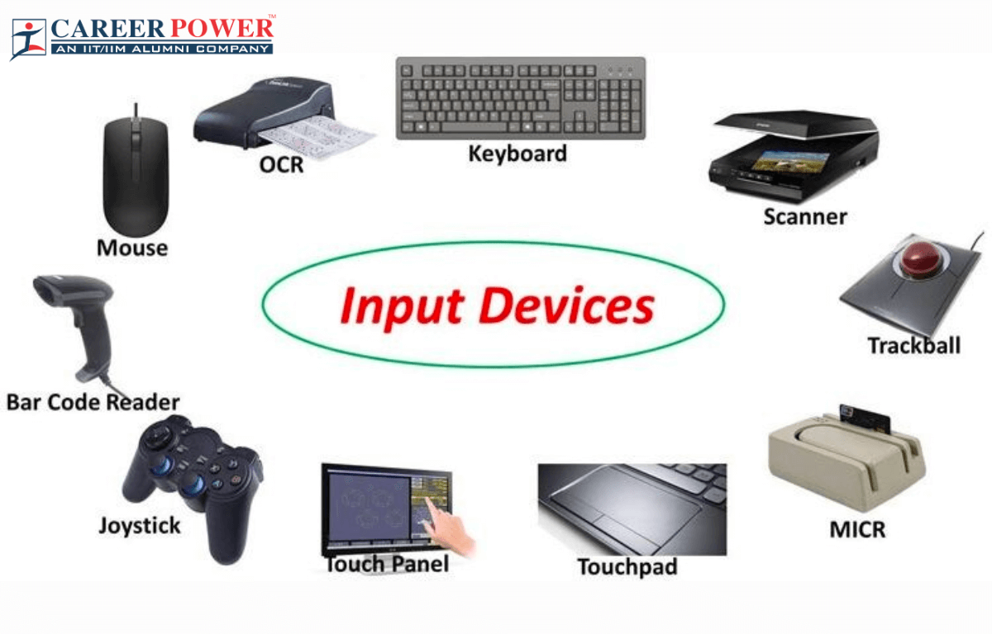



**Output devices**

They are used to produce or display already processed data. After data execution to information. It is sent to either output resource or storage facility, based on the CPU decision.

1. **Printer**

An electronic device for producing an output on paper

1. **Speaker**

A device that produces sound projection from a coiled magnetic element. It generates an output after obtaining a voice from either another device or microphone.

1. **VDU**

A screen for displaying virtual information. They include monitors, projectors and other display screen.

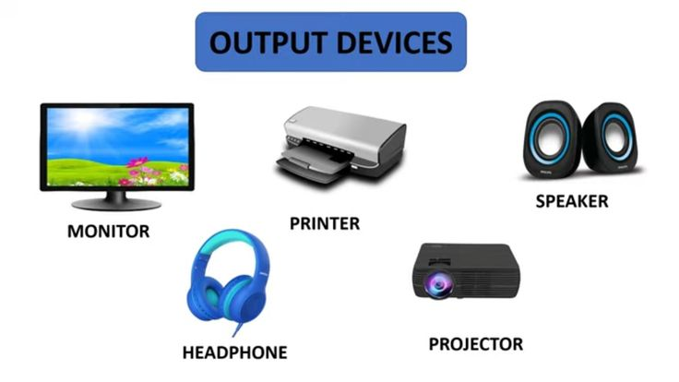

**Storage devices**

They are used to save records for future reference.

**Types of computer storage devices**

***Main memory***

**RAM** – a volatile Random Access Memory used to temporarily hold information that is being executed

by the CPU.

Volatility – ability of a memory to loose data when the power goes off.

RAM types include Dynamic and Static RAM.

Examples: DDR, DDR1, DDR2, DDR3, DDR4, DDR5, DDR6, DDR7

**ROM** – Read Only memory; a memory type that stores permanent instructions that cannot be erased by

normal user operations.

***Types of ROM***

MROM

UVROM

PROM

EPROM

EEPROM

***Secondary memory***

* HDD – Hard Disk Drive
* SSD – Solid State Disk
* Flash drive
* Memory card
* Floppy disks
* CD drives – Compact Disk (CD-R, CD-RW, CD-ROM, magnetic tapes, laser beam tapes)
* External Disks
* 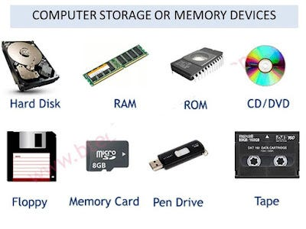Diskettes



**Computer Software**

Set of programs and instructions that guides the user on what to do with the hardware to achieve its operations.

Software’s are divided into two:

1. ***Application soft ware***

Programs designed to perform specific needs of a user. They include web browsers, word editors, spreadsheet applications, DBM Systems, calculators, social media applications, etc.

1. ***System Software***

Programs and instructions designed to operate at the hardware level and ensures its operations are in order. It includes;

* Utility software
* Operating system

**Utility software**

Devices which help in device management activities such as disk scanning, anti-virus and other maintenance services.

**Operating system**

Software that manages hardware and software resources on a computer or device. It acts as an intermediary between users and the computer hardware, enabling users to interact with the machine and run applications.

Key functions of an operating system include:

1. **Resource Management**: It allocates resources such as CPU time, memory, and storage to various applications and processes, ensuring they can operate effectively without interfering with each other.
2. **User Interface**: It provides a user interface (UI) that allows users to interact with the computer. This can be a graphical user interface (GUI) with windows, icons, and menus, or a command-line interface (CLI) where users type commands.
3. **File Management**: It organizes and controls access to files and directories on storage devices, providing features for creating, deleting, and modifying files and folders.
4. **Process Management**: It handles the execution of processes, manages process scheduling, and ensures that different processes can run concurrently without conflicts.
5. **Device Management**: It controls and communicates with peripheral devices like printers, keyboards, and disks, using device drivers to facilitate this interaction.
6. **Security and Access Control**: It enforces security measures by managing user permissions and protecting data from unauthorized access or modifications.

Popular examples of operating systems include:

* **Windows** (by Microsoft)
* **Macintosh OS** (by Apple)
* **Linux** (an open-source OS with various distributions like Ubuntu and Fedora)
* **Android** (used in mobile devices)
* **iOS** (by Apple for iPhones and iPads)

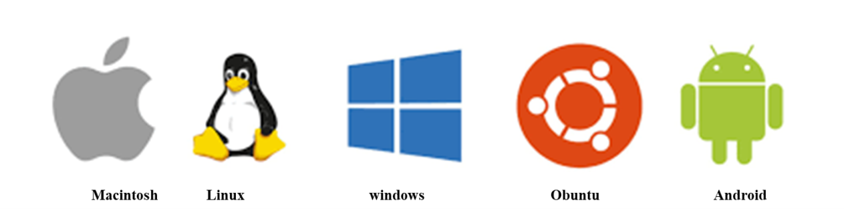Each operating system has its own set of features and user experiences, tailored to different types of hardware and user needs.

**Parts of a mouse and its technics**

* **Clicking**: Pressing and realizing the left mouse button once to select items.
* **Double clicking**: Pressing the left button twice in a quick succession to open programs
* **Right clicking**: Pressing and releasing the right mouse button once to display menu options.
* 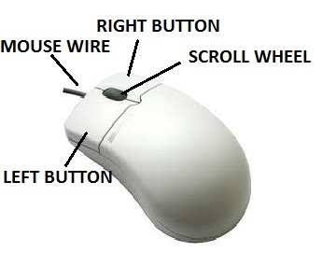**Dragging and dropping:** Pressing and holding the left mouse button on an item, moving it from one point and releasing it to a new location.



**PARTS OF THE KEYBOARD**

1. **Functional keys**

They range from F1-F12 and are majorly used for system settings

1. **Alphanumeric keys**

Has letters A-Z, numbers 0-9, Tab Key( ), Caps Lock, Space Bar, Enter Key ( ) and The Back Space Key.( )

**Caps lock key :** Lets the user to type either in upper or lower case**.**

**Tab key :** Used for uniform spacing/ creating new entries

**Space bar :** Create space between words during typing.

**Enter key :** Moves cursor to the begging of a new line/begins a newparagraph

**Backspace key :** Deletes characters from right to left on the same line.

1. **Special keys :** Comprises of the Escape, Shift, Alternate and Control Keys.

**Escape key :** For quitting unexpected programs.

**Shift keys :** For typing in upper case when typing on lower case and vice versa.

**Alt keys :** for closing program (ALT + F4)

**Control keys**

**Uses of special keys**

Ctrl + A………………………………………………… highlight all

CTRL+B ……………………………………………………… Make text bold

CTRL+C………………………………………………………Copy text

CTRL+D………………………………………………………font specifications

CTRL+E……………………………………………………… align to Centre

CTRL+F……………………………………………………… find menu

CTRL+G……………………………………………………… group items

CTRL+H……………………………………………………… help menu

CTRL+I……………………………………………………… make text Italic

CTRL+J………………………………………………………justify text

CTRL+K………………………………………………………Open hyperlink wizard

CTRL+L………………………………………………………Align text to the left

CTRL+M………………………………………………………

CTRL+N………………………………………………………Open new file page

CTRL+O………………………………………………………Open existing recent files

CTRL+P………………………………………………………Print

CTRL+Q………………………………………………………

CTRL+R………………………………………………………Alight text to the right

CTRL+S……………………………………………………… Save

CTRL+T………………………………………………………Open tabs in a web browser

CTRL+U……………………………………………………… Underline text

Ctrl + V ………………………………………………….……. Paste items

Ctrl + X Copy + delete …………………………………..…… Permanently delete items

Shift + F3 ……………………………………………….……. Change case of letters

Ctrl+Shift+>………………………………………………….. Increase font size

Ctrl+Shift+<…………………………………………………... Decrease font size

Shift + Arrow Keys…………………………………………. Selects one letter at a time

Shift + Ctrl + Arrow keys ………………………………….. Selects one word at a time

Shift + End or Home ………………………………………. Selects lines of text

**Cursor movement and editing keys**

**The arrow keys**: Pressing the right or the left moves the cursor to the right or left

respectively while pressing the up or down keys moves the cursor upward

or downward respectively.

**Page up and page down keys**: Moves the cursor one page up or one page down in case the pages are many.

**Home and end keys** : Pressing home moves cursor to the begging of the current line while

pressing end moves cursor to the end of the current line.

**Delete keys :** erases character from left to right at the cursor position.

**Numeric keys:**

Has the numbers 0 - 9 and the arithmetic entries. Numeric keys can only be used when the number lock key is switched on, thus when the number lock key is off; they function as the cursor movement keys.

**BOOTING/STARTING POWER**

This is the process by which a computerloads its system files in the main memory. It’s the process of opening the computer.

There are two types of booting;

1. **Cold booting**

This is done when the computer was originally off and is switched on by pressing the power button on the system unit.

When the power button is switched on, a cooling sound is heard from the CPU fan.

Complementary Metal Oxide Semi-conductor (CMOS) is a battery that stores some charges in form of power to boot up the device. CMOS initializes the ROM module of the hardware which then wakes up the Operating system. The operating system checks the available connections such as Keyboard, Mouse and other hard drives This is done through a process called Power OnSelf-Test (POST) which if facilitated by Microsoft BIOS. The operating system starts the processor (CPU), after which it loads other available programs to the memory.

1. **Warm booting**

It’s done when the computer was originally on and is forced to restart by pressing the restart button on the monitor.

Before warm booting, ensure that all the opened programs are closed to avoid losing data and avoid tampering with the system software programs and other internal PCB powered components.

**Central Processing Unit (CPU)**

The CPU also the processer is the main system cabinet of the micro computer system that decodes and executes instruction in a computer. It’s the brain of the computer.

***Parts of the CPU***

1. **Control Unit (CU)**

Coordinate all the processing activities in the CPU as well as the input, out and storage operations.

It directs the flow of information in the computer (input, output and storage).

1. **Arithmetic and Logic Unit. (ALU)**

It carries all the arithmetic and logic operations

1. **Main memory**

Provides the storage location for data and instructions accessed by the control unit.

1. It hold data awaiting processing
2. Holds data that has been processed waiting to be outputted
3. Holds data that has been processed and awaits allocation to a resource.

The main memory has two main parts;

**COMPUTER LABORATORY**

Computer laboratory is a room set aside for computer installation and provides conducive environment for computer studies operations.

***Safety measures in a computer laboratory***

Ensuring safety in a computer lab involves addressing both physical and digital aspects to protect users and equipment. Here are some key safety measures to consider:

**Physical Safety**

1. **Ergonomics**: Ensure that workstations are set up to promote good posture and reduce strain. **Cable Management**: Keep cables organized and secured to prevent tripping hazards. Use cable ties, clips, or cable management trays to keep cords out of walkways.
2. **Ventilation and Temperature Control**: Ensure adequate ventilation and air conditioning to prevent overheating of computers and equipment. Computers generate heat, so good airflow is essential.
3. **Fire Safety**: Install smoke detectors and fire extinguishers in the lab.
4. **Emergency Procedures**: Have clear procedures for emergencies such as fires, medical incidents, or power outages.
5. **Cleanliness**: Maintain a clean environment to prevent dust build-up, which can affect equipment performance and increase the risk of fire. Regularly clean work surfaces and equipment.
6. **Electrical Safety**: Use surge protectors to safeguard against power surges and ensure that all electrical installations are up to code. Avoid overloading power strips and use only certified equipment.

**Digital Safety**

1. **Password Protection**: Implement strong password policies for user accounts and regularly update passwords. Encourage the use of multi-factor authentication where possible.
2. **Data Backup**: Regularly back up important data to prevent loss in case of hardware failure or other issues. Ensure backups are stored securely, either offsite or in the cloud.
3. **Antivirus and Anti-Malware**: Install and maintain up-to-date antivirus and anti-malware software to protect against malicious threats. Schedule regular scans and updates.
4. **Network Security**: Use firewalls and secure network configurations to protect against unauthorized access and cyber-attacks. Encrypt sensitive data transmitted over the network.
5. **Software Updates**: Keep operating systems and software updated to patch security vulnerabilities. Enable automatic updates where feasible.
6. **User Training**: Educate users on best practices for digital security, such as recognizing phishing attempts, avoiding suspicious links, and not downloading unauthorized software.
7. **Access Control**: Restrict physical and digital access to sensitive areas and data. Use user permissions and access controls to ensure that individuals only have access to the information and resources they need.
8. **Incident Response**: Have a plan in place for responding to security incidents, including data breaches or malware infections. This plan should include steps for containment, investigation, and recovery.

**CLASSIFICATION OF COMPUTERS.**

1. **Physical size**

***Super computers.***

They are the biggest most powerful and most expensive type of computers used in scientific research and weapon analysis.

***Mainframe computers***.

A smaller, less expensive and less powerful compared to the super computers. They are used in government agency and bigger companies like broadcasting studios.

***Mini computers***

Are used in research institutes and less powerful compared to the main frame computers.

***Microcomputers***

They are the smallest, the cheapest and less powerful types of computers mainly used in learning institutions.

**Examples of micro computers**

1. ***Desk top computer :*** Are potable, designed to be placed on top of an office desk.
2. ***Laptop computer :*** Potable, briefcase like designed to be used by pressing it on lap
3. ***Palm top :*** smaller enough to fit in the pocket and can be held in hand.
4. **Functionality**

***Analogue computers***

*These computers process data by measuring changes in physical magnitude e.g. temperature, speed etc.*

***Digital computers***

*Their operations are based on and off. They process automatic data by electricity.*

***Hybrid computers***

They have characteristics of analogue computers and digital computers

**Application areas of computers**

### 1. ****Business and Finance****:

* **Accounting and Finance**: Computers handle financial transactions, accounting, budgeting, and financial analysis.
* **Customer Relationship Management (CRM)**: Manage interactions with customers, track sales, and improve customer service.
* **Enterprise Resource Planning (ERP)**: Integrate and manage core business processes, such as supply chain, manufacturing, and human resources.
* **E-commerce**: Facilitate online transactions and manage online stores.

### 2. ****Education**:**

* **Online Learning**: Platforms for distance education, virtual classrooms, and educational resources.
* **Classroom Technology**: Tools like interactive whiteboards, student response systems, and educational software.
* **Research and Data Analysis**: Software for data analysis, simulation, and academic research.

### 3. ****Healthcare****:

* **Electronic Health Records (EHR)**: Store and manage patient medical histories and records.
* **Medical Imaging**: Analyze and process images from MRI, CT scans, and X-rays.
* **Telemedicine**: Provide remote consultations and medical services through video conferencing and online platforms.
* **Health Monitoring**: Track and analyze health data using wearable devices.

### 4. ****Science and Research****:

* **Data Analysis**: Perform complex calculations, simulations, and data processing for scientific research.
* **Modeling and Simulation**: Create simulations for physical phenomena, climate models, and molecular biology.
* **Laboratory Information Management Systems (LIMS)**: Manage and track laboratory samples, experiments, and data.

### 5. ****Engineering and Manufacturing****:

* **Computer-Aided Design (CAD)**: Design and model structures, products, and systems.
* **Computer-Aided Manufacturing (CAM)**: Control manufacturing processes and machinery.
* **Automation and Robotics**: Manage automated systems and robotic equipment in production lines.

### 6. ****Entertainment and Media****:

* **Gaming**: Develop and play video games, both single-player and multiplayer.
* **Digital Media Production**: Create and edit images, videos, music, and animations.
* **Streaming Services**: Provide on-demand access to movies, TV shows, and music.

### 7. ****Government and Public Services****:

* **Administrative Systems**: Manage records, taxation, and public services.
* **Public Safety**: Support emergency response systems, crime tracking, and surveillance.
* **E-Government**: Facilitate online services for citizens, such as renewing licenses and accessing government information.

### 8. ****Transportation and Logistics****:

* **Navigation and Routing**: Use GPS and mapping software for route planning and navigation.
* **Fleet Management**: Monitor and manage vehicle fleets for logistics and transportation companies.
* **Traffic Management**: Analyze and control traffic flow and transportation infrastructure.

### 9. ****Telecommunications****:

* **Network Management**: Manage and optimize telecommunications networks and infrastructure.
* **Communication Systems**: Support voice, video, and data communication services.

### 10. ****Retail and Consumer Services****:

* **Point of Sale (POS)**: Process sales transactions and manage inventory in retail settings.
* **Customer Analytics**: Analyze consumer behavior and preferences to enhance marketing strategies.

### 11. ****Social Networking****:

* **Platforms**: Facilitate online social interactions, content sharing, and community building through social media networks.

### 12. ****Artificial Intelligence and Machine Learning****:

* **Natural Language Processing**: Develop systems for understanding and generating human language.
* **Predictive Analytics**: Use data to make predictions and decisions in various applications, from marketing to healthcare.

### 13. ****Artificial Intelligence and Machine Learning****:

* **Natural Language Processing (NLP)**: Develop systems that understand and process human languages, such as chatbots and language translation.
* **Predictive Analytics**: Analyze data to make predictions and decisions, used in finance, healthcare, marketing, and more.

**ADVANTAGES OF USING COMPUTERS.**

• **Efficiency and Speed**: Computers can process vast amounts of data quickly and perform repetitive tasks with high efficiency. This speeds up work processes and improves productivity.

• **Storage and Retrieval**: They can store large amounts of information in various forms (text, images, videos) and allow for quick retrieval and organization.

• **Communication**: Computers enable instant communication through emails, messaging apps, and video conferencing, facilitating global connectivity and collaboration.

• **Access to Information**: The internet, accessible via computers, provides a wealth of information and resources on virtually any topic, supporting education, research, and self-learning.

• **Automation**: They can automate complex processes in industries such as manufacturing, finance, and logistics, reducing the need for human intervention and minimizing errors.

• **Entertainment**: Computers offer a wide range of entertainment options, including games, movies, music, and social media platforms.

• **Data Analysis**: Advanced computing tools and software enable detailed data analysis and visualization, supporting decision-making in various fields like business, science, and engineering.

• **Customization**: They allow for the customization of applications and systems to meet specific needs, from personal productivity to specialized professional tasks.

• **Accessibility**: Computers assist individuals with disabilities through adaptive technologies, making tasks easier and more accessible.

**DISADVANTAGES OF COMPUTER.**

• **Health Issues**: Prolonged use of computers can lead to health problems such as eye strain, repetitive strain injuries, and poor posture. Sedentary behavior associated with excessive computer use can also contribute to various health issues.

• **Security Risks**: Computers are vulnerable to security threats like malware, viruses, hacking, and data breaches, which can compromise personal and organizational information.

• **Dependency and Over-reliance**: Heavy reliance on computers for information and tasks can lead to dependency, reducing the ability to perform tasks manually or without technological support.

• **Privacy Concerns**: The collection and storage of personal data by various applications and websites can lead to privacy issues and unauthorized use of sensitive information.

• **Environmental Impact**: The production and disposal of computers contribute to electronic waste and environmental pollution. The energy consumption of data centers and devices also impacts sustainability.

• **Cost**: While the price of computers has decreased, maintaining up-to-date hardware and software can still be costly. Additional expenses include software licenses, subscriptions, and peripheral devices.

• **Technical Issues**: Computers can experience hardware and software malfunctions, which may require technical support, repair, or troubleshooting, sometimes resulting in downtime or lost productivity.

• **Digital Divide**: Not everyone has equal access to computers and the internet, leading to disparities in opportunities for education, work, and communication.

• **Distraction**: The vast array of entertainment and social media options can lead to procrastination and distraction, affecting productivity and focus.

**WINDOW**

Window is any program opened to occupy the desktop.

**W -** Window

**I** - Icon

**M** - Mouse

**P** – Pointing device

***Window*** : It’s any opened program to occupy the desktop.

***Icon*** : Is pictorial presentation of a command or program.

***Mouse*** : Controls the pointer display on the screen by pointing and clicking.

***Pull down*** : Acquiring more commands in form of a list (System navigation).

***Desktop*** : Is a computer working area is the first window you see open on a computer it contains numerous small pictures called icons and the task bar.

**COMPONENTS OF A WINDOW**

**Title bar** : It’s the upper most bar of a window and it has the control box title of active program minimization button restoration button/maximization button and the close button

**Menu bar** : Is the next bar below the title bar and has different commands.

**Tool bar** : Found within the menu bar and contains different tools with various options to choose from.

**Ruler** : For measuring the page.

**Scroll bars/ Strollers :** Are found at the right and down parts of window. They are used to move across or along to see the information that cannot fit in the window.

**Status bar** : It shows the data entered in the computer.

**Task bar** : Shows the program opened in a computer and it has the start button, system clock icons of running programs and icons of minimized windows.

**Desktop** : Computer working area.

**CREATING FOLDERS AND FILES**

**Folders**:

1. A folder is a file within a digital system where group of folders and computer documents are stored.

***Procedure for creating folder and sub folders.***

1. Right click on the black desktop.
2. Point to new.
3. Click folder.
4. Type the folder name and press enter/click blank desktop.

**Subfolder.**

1. Double click the folder on which you want to create a sub folder.
2. Point to new.
3. Click folder and click the sub folder name and press enter.

**Renaming folders.**

1. Right click the folder.
2. Click rename.
3. Type the folder name and press enter.

**Deleting files and folders.**

1. Right click the files you want to delete.
2. Click delete.
3. From the dialogue box click yes.

**Restoring deleted files**

1. Open the recycle bin
2. Find the file you want to restore and right click.
3. Clicks restore.

**Deleting files permanently.**

1. Open the recycle bin, find for the file to delete.
2. Right click on it.
3. Click delete

**RECYCLE BIN**

This is where all the unwanted files and documents are deleted and thrown into.

**CREATING A TEXT DOCUMENT**

A **text** file is a kind of computer file that is structured as a sequence of lines of electronic **text.**

It’s a digital file that is capable of handling text contents. You can type and store your text inside it.

**Procedure**

1. Right click the desktop.
2. Point to new.
3. Click text document. l
4. Type the name of the text document and press enter.

**Methods of opening a document**

1. Double click on the program icon.
2. Right click the program icon then open.
3. By using the run command.

**Methods of closing the program.**

1. Clicking the close button.
2. Double click the control box.
3. Right clicking the title bar then click close.
4. Clicking file/office button then click exit.
5. From the keyboard press Alt +F4.

**Saving created document.**

1. Click file /office button.
2. Click save as.
3. Select location for your document.
4. Type the document name.
5. Clicks save.

**Copying files and documents.**

1. Highlight the text.
2. Right click then copy.
3. Open another document.
4. Right click then paste.

**Changing windows display/desktop background**

1. Right click the desktop.
2. Click properties/personalize.
3. Select the background for your desktop.
4. Click apply then ok.

**Learn how to set up a printer.**

1. Click the Start button.
2. Click the Help and Support menu item.
3. The Help and Support window will open.
4. In the Search box, type: “setting up a printer,” as shown in Figure 1.19.
5. Click the Search Help button.

**Shutting Down Your Computer**

1. When you have finished using your computer, it is important to shut it down properly.
2. Windows will close any open applications, save settings, and remove temporary files.
3. When you’re ready, take the following steps to shut down your computer.
4. Click the Start button.
5. Click the arrow next to the Lock button.
6. Click the Shut Down option to turn off the computer.
7. The Sleep feature can be used when you wish to conserve energy. It will power down the hard.
8. Drive and monitor and retain information in memory. If there is a power interruption, information.
9. In memory will be lost, so it is wise to save your documents before you use the Sleep feature.

**Changing date and time**

1. Click start
2. Click control panel
3. Click time and date
4. Set date, time month and the year then click ok

**COMPUTER VIRUS**

Are the programs that interfere with the normal functioning of the computer.

**Symptoms of an infected computer**

1. Takes long to open a program
2. Unnecessary messages appear on the screen
3. Created documents disappears

**Transmission of computer virus**

1. Through networks
2. By sharing secondary storage devices such as flash disks already affected
3. By downloaded programs

**Protection against virus**

1. Download antivirus in your computer

Examples of antivirus:

* Kaspersky
* 360
* Smadav
* Avast

1. Avoid sharing secondary storage devices

**MICROSOFT WORD**

Microsoft word (an example of a word processor) is application software that mainly enable the user to create simple documents such as letters and typesetting basics such as making formatting simple statements. This package focuses on expounding more on the meaning bar and dipping its explanation on the tools of the menu commands.

**STARTING A MICROSOFT WORD**

***Procedure***

1. Open the start button of your PC
2. On the search tab, type “Microsoft word”
3. Click to open

Microsoft word has the following programs within the menu bar:

**Home** : Clipboard, Fonts, Paragraph, Styles, and Editing.

**Insert** : Pages, Tables, Illustrations, Links, Header & Footer, Text, and Symbols

**Page Layout** : Themes, Page Setup, Page Background, Paragraph, Arrange

**References :** Table of Contents, Footnote, Citation & Bibliography, Captions, Index, and Table of contents

**Mailings :** Create, Start Mail Merge, Write & Insert Fields, Preview Results, Finish

**Review :** Proofing, Comments, Tracking, Changes, Compare, Protect

**View :** Document Views, Show/Hide, Zoom, Window, Macros

To remove the toolbar, right click on the blue section beside the Ribbon. Choose Minimize the Ribbon. To view again, do the same.

**The Cursor**

1. The cursor is the short vertical flashing line on your screen.
2. The cursor shows you where you will start typing in a Word document.
3. When you are using the Tools in Microsoft Word your cursor will change to an arrow. This is called a pointer.

**Using the Keyboard in MS Word**

1. The **arrow keys** on your keyboard move your cursor around.
2. To make a letter a capital letter.
3. Hold down the Shift and the letter key at the same time.
4. For the signs on your keyboard.
5. Hold down the **Shift** and the number key at the same time.
6. The Shift keys are on both sides of the keyboard.
7. The Space bar makes spaces between words when typing. Tap the bar one time to make a space.
8. Use the **Enter key** to move your cursor to finish the line and make a new one.
9. The **Backspace key** deletes everything to the **left** of the cursor.
10. The **Delete key** will erase everything to the **right** of the cursor.
11. To make the cursor go to the end of the line press **End.**
12. To make the cursor go to the start of a line press **Home.**
13. To make the cursor go to one **page up/down** press **Page Up/Page Down**.
14. To make the cursor go to the top/end of the document press **Ctrl+Home/Ctrl+End.**

**Selecting text**

1. Put the cursor at the beginning or end of the words you want to select.
2. Put your finger on the left mouse button.
3. Hold down the left mouse button.
4. Move the mouse across the words.
5. Lift up your finger.

The word will be highlighted in blue. When this is done, you can move words or change the size, the colour, and the style of the words on the computer

Using format painter

It is a feature in home tools used to copy formatting options from a text to the other.

Procedure

**APPLYING PAGE BORDERS**

1. Click page layout.
2. Click page borders.
3. Select the border and click ok.

**Bullets and numbering**

1. Highlight the text.
2. Click bullets or numbering.
3. Choose the style of bullet or numbering you want and click on it.

**Change Text Color**

1. Select the text and click the Colors button included on the Font Group of the Ribbon

**OR**

1. Highlight the text and right click and choose the colors tool.
2. Select the color by clicking the down arrow next to the font color button.

**Highlight Text**

1. Select the text
2. Click the Highlight Button on the font Group of the Ribbon, or
3. Select the text and right click and
4. Select the highlight tool
5. To change the color of the highlighter

**APPLIYING A WATERMARK**

1. Click on down arrow next to the highlight button.
2. Click design on the Menu Bar, click water mark.
3. Click custom watermark, type your water mark.

**Changing font colour**

1. Select layout, change font, colour and size.
2. Clicks apply then close.

**PAGE FORMATING**

**Modify Page Margins:**

1. Click the Page Layout Tab on the Ribbon.
2. On the Page Setup Group, Click Margins.
3. Click a Default Margin, or
4. Click Custom Margins and complete the dialog box.

**Orientation, Size of the Page, or Columns:**

1. Click the Page Layout Tab on the Ribbon.
2. On the Page Setup Group, Click the Orientation, Size, or Columns drop down menus.
3. Click the appropriate choice.

**Page Border and Color.**

1. Click the Page Layout Tab on the Ribbon.
2. On the Page Background Group, click the Page Colors or Page Borders drop down menus.

**Insert Common Header and Footer Information.**

1. To insert Header and Footer information such as page numbers, date, or title, first, decide if you
2. want the information in the header (at the top of the page) or in the Footer (at the bottom of the page), then:
3. Click the Insert Tab on the Ribbon
4. Click Header or Footer
5. Choose a style

**MICROSOFT WORD**

**MICROSOFT WORD**

**MICROSOFT EXCEL (SPREADSHEET)**

**Overview of the Excel Work Space**

Microsoft excel (spreadsheet) is an application software that is commonly used for arithmetical and logical functions

***Titles, Windows, and Worksheets***

The title bar at the very top of your Excel screen reminds you that you're in Excel. If your workbook is expanded to take up the maximum amount of screen space, its title

Bar is merged with Excel's title bar to look like this: **Microsoft Excel - Book1**. If your

Workbook is taking up less than the maximum amount of screen space it's displayed in

Its own window with its own separate title: **Book1**.

Book1 is the default name for an Excel workbook until you assign it another name.

Book1 is composed of multiple worksheets. Take a look at the bottom of the Book1

Window to see the tabs labeled *Sheet1, Sheet2, Sheet3*, etc. Use the mouse to click any

**TERMS USED IN EXCEL**

**Cell** :Is where the raw and columns intersect.

**Worksheet** : Is a sheet of paper where problems are solved in.

**Workbook** : Is a collection of worksheets.

**Name box/Cell bar/cell reference** : Shows the active cell in a work sheet.

**Formula bar** : Shows the formula entered in a calculation.

**Merging cells**

1. Highlight the cells you want to merge.
2. Click home.
3. Click merge and Centre.
4. Click merge cell.

**DELETING THE DATA**

1. Highlight the range to be affected.
2. Click on the edit menu, point to clear the contents delete.

**CHANGING THE FONT COLOUR, SIZE AND TYPE**

**Procedure**

1. Highlight the data to be affected.
2. Click on the format menu and choose cell option.
3. Activate the font type, then select the desired colors, size then click ok.

**ADJUSTING COLUMN WIDTH.**

It’s the process of changing the column width to any size as required by the user.

**Procedure**

**Method a) Best fit**

1. Position the mouse pointer at right boundary of the column header so that the shape changes to a cross sign **(+**) then double click.

**Method b) Dragging method.**

1. It’s a method used to position a mouse pointer and it changes to a four pointer headed arrow, press the left button and move manually.

**Method c).By units.**

1. Select the column to be adjusted.
2. Click on the format menu and choose column then width.
3. Specify the column width.
4. Finally click ok.

**INSERTING OF ROWS AND COLUMNS.**

1. Select where you want the row/column to appear.
2. Click on the insert menu and choose row/columns.

***Or***

1. Highlight the position where to insert rows and columns
2. Right click the mouse once and from the drop down list that appears, click insert rows/columns.

**APPLYING PICTURE BACKGROUND TO SHEETS**

This is a command used to change the shading style of a page or entire workbook.

**Procedure**

1. Click on the format menu, point to sheet then background.
2. Choose the desired image then click insert command button.

**HIDING WORKSHEET**

It’s the process of removing a worksheet from a view.

**Procedure**

1. Click on the format menu and choose sheet.
2. Highlight the hide option

**UNHIDEING WORKSHEET**

**Procedure**

1. Click on the format menu, point to sheet then unhide option.
2. Specify the sheet to unhide from the dialog box then click ok.

**HIDING WORKBOOK**

1. Open the workbook to hide.
2. Click on the window menu then choose hide.

**UNHIDING WORKBOOK.**

1. Open the workbook to unhide.
2. Click on the window menu and choose unhide.
3. From the window that appears, specify the workbook to unhide then click ok.

**SORTING DATA**

It’s a command used to rearrange the data in a specific order ascending or descending

**Procedure;**

1. Select the range of data.
2. Click on the data menu and select sort.
3. From the window that appears, specify the correct order then click ok.

**PROTECTING A WORKSHEET.**

It’s the prevention and or changing of the worksheets data/records made by either modifying or adding new records/data.

**Procedure;**

 Click on the tool menu, point to protection then protect sheet.

 Type the password and confirm, click ok then save the changes

**FORMULAS, FUNCTIONS AND AUDITING OF WORKBOOK**

A formula is a command feature or an instruction to perform calculations. They perform mathematical operations ranging from very simple arithmetic problems to complex scientific, financial and statistical functions.

***Or***

It’s a predefined formula that accomplishes a mathematical operation based on a given condition or criteria in a worksheet. It comprises of: -

**Function**

A function is an inbuilt formula that performs specific arithmetic operations they are grouped into the following: -

1. Statistical function e.g. Average, Count, Max, Min, Mode.
2. Logical functions e.g. If, count, If sum, If.
3. Mathematical functions e.g. sum, product, division, cosine
4. Information functions e.g. this return information about the cells, range, operating systems etc.
5. Engineering functions e.g. Binary, Hexadecimal.

**AUTOFILTER**

It’s a feature used to find and extract a record based on a given condition or criteria.

**Procedure**

1. Select the range of the data that you are working on.
2. Click on the data menu, point to filter then auto filter.
3. From the records select the filter buttons.
4. Click on custom.
5. Specify your filtrations finally click ok.

**Printing (Ctrl +P)**

To print the current worksheet using Excel's defaults for printing click the *Print* button

On Excel's *Standard* toolbar.

To control Excel’s print options, select *File, Page Setup* to open the *Page Setup* dialog

Box. Note that this dialog has four tabs: *Page, Margins, Header/Footer,* and *Sheet*.

**To fit your printout on one or more pages.**

Click the Page tab and click the Fit to option in the “Scaling” section. If you have a

Spreadsheet that’s just a row or column or two too large to fit nicely on a single page,

This is a lifesaver of an option. It reduces your entire spreadsheet in size just enough to

fit in the space you specify with the Fit to option.

**MICROSOFT ACCESS (DATABASE)**

 This is an application software classified under the data base and is used for record keeping and data analysis. Access organizes its work in different formats known as objects. The objects include:

Table

Forms

Queries

Reports

**Starting Microsoft office access.**

1. Click start button.
2. Point to all programs.
3. Point to Microsoft office access.
4. Creating a database.
5. Click blank data base.
6. Type the file name.
7. Click create.

**Creating tables.**

1. Click create.
2. Click table design on the tool bar.
3. Save the table. The name in this case is the table object name.
4. Fill in the field name and the corresponding datatypes. A fieldname refers to column names that represent data, while datatypes are the nature of data entry of the fieldnames. A primary key is needed to mark the field with unique entries.
5. Click view on the tool bar of either design or home and select datasheet.
6. Fill in your entries and save.

**Selecting data type**.

1. Text/short text –Used for data that includes words.
2. Memo -Used for short texts.
3. Number -Used with data that is in numeric.
4. Date and Time -Used with data that corresponds to dates.
5. Currency –Data in shillings.
6. Yes or No – Used with data requiring finality or decision.
7. Lookup w

**Creating form.**

1. Click creates.
2. Click on form.

**Creating form by form wizard.**

1. Click creates, click more forms.
2. Click form wizard.
3. Select the field for your form and click next.
4. Select the layout and click next.
5. Select the style and click next.
6. Type the name for the form and click finish.

**Creating report by report wizard.**

1. Click create.
2. Click report wizard.
3. Select the field and click next.
4. Confirm your fields and click next.
5. Select the sort order and click next.
6. Select the layout and orientation then click next.
7. Select the style and click next.
8. Type the report name and click finish.

**Inserting buttons.**

1. Use the created form.
2. Click on view and change it to design view.
3. Extend the page coverage.
4. Click on button.
5. Select record navigation.
6. Decide on the function of the button: Go to Next Record, Go to First Record, Go to Previous Record etc.
7. Click on text if it’s a text or picture in case of pictures.
8. Type the name of the button.
9. Click finish.

**Changing logo.**

1. Using form change the view to design view.
2. Click on logo.
3. Select any picture or logo for your document and click apply.

**Creating report.**

1. Click on create.
2. Click on report.
3. Save the report.

**Creating report by report wizard.**

1. Click on report wizard.
2. Select from the available fields and click next.
3. Enter the name of the selected field and chose the order of the report: ascending or descending.
4. Click next and choose the layout of the report as Columnar, Tabular or Justified.
5. Select page layout either as landscape or portrait.
6. Click next then finish.

**Create query by query wizard.**

1. Click create.
2. Click query wizard.
3. Click simple query wizard then click ok.
4. Select the fields for your query and click next.
5. Type the title for the query and click finish.

**Creating query by query design.**

1. Click cerate.
2. Click query wizard.
3. Add available tables.
4. Select whether to show or not show the selected field.

**Sort and filter.**

1. Highlight the column in which you want to sort.
2. Click sort and filter or text filter.
3. Then select the type of your sorting.

**MICROSOFT POWERPOINT (PRESENTATION)**

 Used for making presentations, slideshows and advertisements.

**Creating slides**

1. Click home.
2. Click new slide.
3. Select the slide style and click.

**Creating presentations**

1. Click the first slide.
2. Click to add title and type the title for your presentation.
3. Click to add text and discuss your title above.
4. Create another slide **and repeat the above steps.**

**Designing slides**

1. Click design.
2. Click themes.
3. Select the style then right click for more ways to apply.

**Using Animation Effects**

1. Animation is a great way to focus on important points, to control the flow of information, and to increase viewer interest in your presentation.
2. You can apply Animation effects to text or objects on individual slides, to text and objects on the slide master or to placeholders on custom slide layouts.
3. There are four different kinds of animation effects in PowerPoint:
4. **Entrance** effects. For example, you can make an object fade gradually into focus, fly onto the slide from an edge, or bounce into view.
5. **Exit** effects. These effects include making an object fly off of the slide, disappear from view, or spiral off of the slide.
6. **Emphasis** effects. Examples of these effects include making an object shrink or
7. grow in size, change colour, or spin on its center.
8. **Motion Paths** You can use these effects to make an object move up or down, left or right, or in a star or circular pattern (among other effects).

You can use any animation by itself or combine multiple effects together. For

1. instance, you can make a line of text fly in from the left while it grows in size by applying a **Fly In** entrance effect and a **Grow/Shrink** emphasis effect to it.

To add an animation effect to an object, do the following:

1. Select the object that you want to animate.
2. On the **Animations** tab, in the **Animation** group, click the **More** button, and then select the animation effect that you want.

**Start On Click** (mouse icon): The animation begins when you click the mouse.

**Start with Previous** (no icon): The animation effect starts playing at the same time

as the previous effect in the list. This setting combines multiple effects at the same time.

**Start After Previous** (clock icon): The animation effect begins immediately after the previous effect in the list finishes playing.

**Using Slide Transitions.**

Slide transitions are motion effects that occur in Slide Show view when you move from one slide to the next during a presentation.

**Add a transition to a slide**

1. In the pane that contains the Outline and Slides tabs, click the**Slides** tab.
2. Select the slide thumbnail of the slide that you want to apply a transition to.
3. On the **Transitions** tab, in the **Transition To This Slide** group, click the slide transition effect that you want for that

**Set the timing for a transition**

1. To set the duration of the transition between the previous slide and the current slide, do the following:
2. On the **Transitions** tab, in the **Timing** group, in the **Duration** box, type or select the speed that you want.

To specify how long before the current slide advances to the next, use one of the following procedures:

1. To advance the slide when you click the mouse, on the **Transitions** tab, in the **Timing** group, select the **On Mouse Click** check box.
2. To advance the slide after a specified time, on the **Transitions** tab, in the **Timing** group, in the **After**box, enter the number of seconds that you want.

**MICROSOFT PUBLISHER (PUBLICATIONS)**

 It’s used to publish invitation cards, business cards, fundraising cards, certificates, creating calenders, bronchures, picture-passports etc.

**Starting Microsoft publisher**

1. Click start.
2. Point to all programs.
3. Point to Microsoft office.
4. Click Microsoft office publisher.

**Creating pages in Microsoft office publisher**

1. Click blank page sizes.
2. Choose orientation and page size.
3. Click create or double click the page size.
4. Click insert.
5. Click page.
6. Type number of pages and click ok.

**Inserting border lines.**

1. Click text box.
2. Draw the text box all-round the page.
3. Double click the text box line.
4. Click border art.
5. Select the border and click ok.
6. Click ok.

**Applying background colour and click.**

1. Creating calendar for one month per page.
2. Open publisher.
3. Click calendars.
4. On the time frame, lick one month per page.
5. Click set calendar dates.
6. On start date, click January.
7. On end date click December and click ok.
8. Clicks create.

**Creating calendar for one year per page**

1. Click calendars.
2. Go to time frame and click one year per page.
3. Set the year and click ok.
4. Click create.
5. Right click January.
6. Point to change text.
7. Click edit story in Microsoft word.
8. Change the Sundays and holidays to red.
9. Quit MS word.
10. Repeat the same procedure in every month.

**Inserting picture**

1. Click insert.
2. Point picture.
3. Click from file.
4. Click my computer.
5. Double click local disk.
6. Double click program files.
7. Double click Microsoft office.
8. Double click clipart.
9. Double click PUBCOR.
10. select the picture and click.
11. Click insert.

**Joining the middle pages**

1. Right click between two pages.
2. Click view two pages spread.

**Deleting page**

1. Right click the page you want to delete.
2. Click delete then ok.

**INTERNET, E-MAILING AND NETWORKING**

**Internet**

1. Internet is the world’s biggest computer network or huge connection of computers all over the world.

**Network**

1. A connection between two or more computers or things for the purpose of sharing information.

**CLASSES OF NETWORK**

1. **Local area network**

This is the connection of computers within a given geographical area e.g. schools, hospitals and banks.

1. **Metropolitan area network**

This is the connection of computers within a city to people with common interest.

1. **Worldwide area network.**

Is the connection of computers from all over the world.

**Requirements for internet connectivity**

1. Persona computers.
2. Telephone lines to facilitate the flow of data.
3. Internet service providers.
4. Web browsers.
5. Modem.

**Internet service providers**

These are an organization that provides people with access of the internet through dial up connection at a fee.

Examples include:

1. Safaricom Kenya.
2. Telkom Kenya.
3. Airtel Kenya.
4. Africa online.
5. Nairobi net.

**Personal computers.**

1. Is the full functional system terminal that forms the prime basis of net connectivity.

**Telephone line.**

1. Includes a registered telecommunication line of any service provider e.g. Safaricom, Airtel.

**Modem**

1. Is a device that enhances connection via telephone networks, cables or TV lines between your personal computer and the computer network that provides net access.

**Types of modem**

Internal modem : connected inside the system unit through expansion slots.

External modem : connected through the ports of an external device.

**Internet software browser**

1. These are a program that provides access to information anywhere in the world. They translate codes to display web pages in browser windows.

**They help in**

Lording and viewing web pages in document format.

1. Printing documents.
2. Navigation through the web easily.
3. Accessing electronic mails.
4. Searching for web sites.

***Examples include***

1. Chromes
2. Operamini
3. Mozilla fire fox
4. Internet explore
5. Dorado

**SERVICES OFFERED BY THE NET**

1. **Electronic Mail**
2. You can send or receive easily and faster by just clicking to connect with friends, family and business.
3. **Programming**
4. Application programs are all over the internet in down lording format ranging from graphic software, spreadsheet and many others.
5. **Information**
6. You can search for information about politics, health, religion, science, education and much more.
7. **Entertainment**
8. You can play games, watch latest movies and listen to music online.
9. **Social media**
10. Internet provides variety of socializing websites where individuals, companies and institutions exchange ideas regarding fundamental issues affecting their environment.

**Examples of social media**

1. Facebook.
2. Instagram.
3. Whatsapp.
4. Twiter.
5. To go.
6. Palmchat.

**Web search engines**

1. These are the sites that help to find information in the web they catalogue the information and gives the user interface to enter search criteria. An example is “Google”

**Electronic mail**

1. Refers to the means of communication between two or registered users of the internet by enabling sending correspondence and documents between one another through mail transfer.
2. These are software’s that enable the user to receive

**Email software**

1. Compose and send email e.g. Yahoo, Gmail, Outlook etc.

**Creating an email account**

1. Open your web browser.
2. Select either yahoo or Gmail.
3. click create an account.
4. fill the form given.
5. Click sign up.

**Composing and sending email.**

1. Open the Yahoo or Gmail.
2. Click compose button.
3. Type the recipients address.
4. Type the subject of the message.
5. Type your message in the message box.
6. Click the send button.

**Email address format.**

[**saviourcompcentre@gmail.com**](mailto:saviourcompcentre@gmail.com)

1. saviourcompcentre – is the user name.

2. **@** - symbol for (**at**) it separates the user name from the rest of the address.

3. **Gmail** – is the name of hosting computer in the network i.e. the computer in which the email address is hosted.

4. .**com** -identifies the type of organization offering a particular service and is called domain meaning com mercial institution.

*Examples are*

1. Com – Commercial Services
2. Edu – Educational Institution
3. Mil – Military
4. Net – Networking Services

**Checking mails**

1. Sign in using your email address and password.
2. Click check mail button then in box.
3. In the inbox, click the subject of the mail to be read.
4. Read the mail.
5. Open an attachment if any.

**Attaching files**

1. Sign in using your email address and password.
2. Click compose mail.
3. Type the recipient address.
4. Type the subject of your mail.
5. Under the attachment click browse.
6. Select the document to be attached.
7. Click done.
8. Click send.

**Merits of e-mail**

1. It is an interactive means of communications.
2. Its affordable.
3. It is faster.

**DOMAIN SYSTEM**

www.saviourcomputer.co.ke

www.org.co.ke

1. Level 1 (.ke) - refers to the domain country e.g Kenya
2. Level 2 (.co) refers to the name of the company
3. Level 3 (org.) refers to the name of organization or any none profit-making institution like Kenya red cross
4. Level 4 (www.) refers to the server type i.e worldwide website.

**The world wide website.**

1. Is a collection of files and folders stored in web server link.

**Web server.**

1. A computer that controls and contain information of other clients in the internet.

**Net work**

1. A series of connected elements to an overall structure.

**NETWORKING**

**Networking.**

1. The act of connecting various clients to enhance sharing information.

**Browser.**

1. A software that read and view web sites.

**Home page.**

1. Is the first page you see when you open your browser.

**Web page.**

1. Contains texts graphics, pictures and animations.

**Links.**

1. Accessing pages within a single web site.

**THE HTTP**

1. Hypertext transmission protocol; the language of communication between web clients e.g.(http://)

**THE HTML**

1. Hypertext markup language: used by the web to create and recognize hypertext system.

**URL**

1. Uniform resource locater, the web address of a particular web page, protocol name, organization, suffix.

**THE FULL ADDRESS**

http:/www.saviourcomputers.co.ke

http:// refers to the method of file